Summer School in Barcelona

Many young lawyers of the Alliuris member firms are looking forward to the annual Alliuris Summer School. This year, the Summer School took place from 24 June to 28 June in Barcelona and was organised by our Spanish partner law firm, ^{Marco} Legal. Ten legal trainees from various European countries attended the three-day legal seminar covering several topics such as Competition Law, Legal English Skills, Spanish Legal Proceedings and Commercial Arbitration. During Summer School the participants had many opportunities to share and exchange knowledge and experiences from their own local practices. To stimulate the further exchange, the host firm organised a workshop about the access to law professions in different jurisdictions. Furthermore, the young lawyers visited the office of Marco Legal and had the opportunity to meet many of the Spanish colleagues.
The excellent organisation and the diversified program organised by the host firm guaranteed the success of this year’s Alliuris Summer School. It was an unforgettable experience for all the participants and promoted the friendship between young lawyers within the Alliuris group. The participants remain in contact and look forward to meeting each other again.

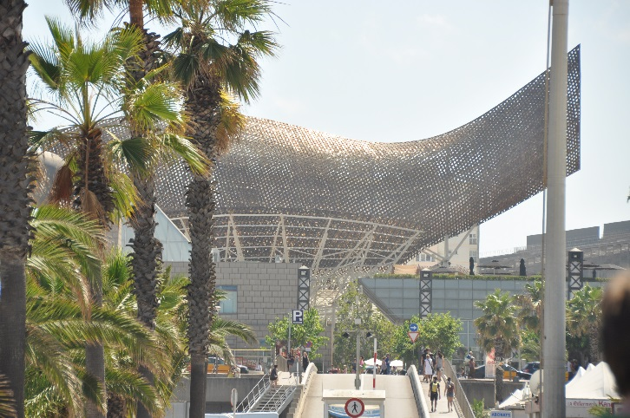
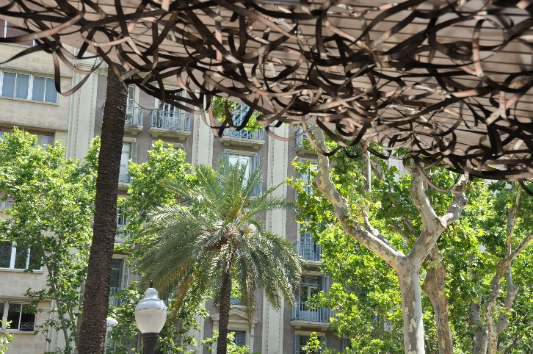

Marco Legal as Hosting Firm

Marco Legal, Abogados & Economistas, S.A.P. was founded in Barcelona in March 2000. The law firm is mainly acting in Corporate Law and Commercial contracts, Tax Planning and Labour legal advice. Beyond that the Spanish office, consisting of a team of 15 lawyers and employees, offers an extensive litigation experience in trial, appellate and arbitration matters to their clients. Ever since the firm was founded, Marco Legal has been very active internationally. The perfect domain of different languages, as well as the knowledge of other countries legal systems positions the law firm as the ideal partner when dealing with cross-border corporate matters. Marco Legal has been a member of the Alliuris Group since 2011. Since the beginning of their membership, the Spanish law firm has been working consistently with many Alliuris firms in numerous cross-border projects.

Competition Law (Lopez)

The first conference was conducted by Santiago Nadal, partner at SNA and former member of the BCN Bar Board, and Monica López. Both are experts in the area of Competition Law. The seminar started with an introduction to the Spanish Competition Law. In Spain, there are two ways to start a proceeding in Competition Law –a proceeding can either start at a civil court or at the administration. The aim of Competition Law is to regulate anti-competitive conduct by companies. Therefore, Competition Law consists of three main elements:

Prohibiting agreements or practices that restrict free trading and competition between businesses. This includes in particular the repression of free trade caused by cartels. Cartels are agreements and/or concerted practices between two or more competitors aimed at coordinating their competitive behaviour on the market and/or influencing the relevant parameters of competition through practices such as the fixing of purchase or selling prices or other trading conditions, the allocation of production or sales quotas, restrictions of imports or exports and/or anti-competitive actions against other competitors. Cartels are banned under European competition law. Banning abusive behaviour by a firm dominating a market or anti-competitive practices that tend to lead to such a dominant position. The abuse of a dominant position covers practices such as the development of concepts of predatory pricing, the alignment of prices with those of competitors and the recoupment of losses suffered. Hindrances of competition include, in particular, the refusal to deal and to discriminatory measures. Supervising the mergers and acquisitions of large corporations. Collusion, bribery and corruption are strictly forbidden. The conference was very interesting for the participants because the main areas of Competition Law were discussed on the bases of actual cases.

Legal English Skills (Tonia)

In the afternoon, Mr Patrick Axon, who regularly gives legal English lessons to lawyers, taught Legal English Skills to the participants. Contrary to the typical way of holding an English course, Mr Axon discussed about morality, duties, rights and responsibilities with the young lawyers. He presented legal situations to the attendants which faced complex ethical problems. To solve those problems, he first created a “legal questionnaire” which included the following exercises: What is the law? Analyse the law. Subsequently, Mr Axon asked the lawyers to criticise the law and to ask themselves which part of the legal solution doesn’t feel satisfactory to them. At that point, Mr Axon started his English lesson and talked about the moral principles of moral reasoning and categorical reasoning. After this really impressive discussion, the group started to discuss about corporate responsibility and business ethics. The participants had to face the question how relevant corporate responsibility is to the business world today. Therefore, they discussed about the following quotes:

- “Greed is good. Greed is right. Greed works.” – Gordon Gekko, in the film “Wall Street”
- “A business that makes nothing but money is a poor kind of business.” – Henry Ford, US industrialist
- “Corporation, an ingenious device for making profit without individual responsibility.” – Ambrose Bierce, US columnist and writer
- “The one and only social responsibility of business is to make profits.” – Milton Friedman, US economist

Towards the end of the English lesson, Mr Axon practiced some grammar with the group. On top of which, he talked about techniques how to improve English as a foreign language and how to be more confident of speaking and using English. This was very interesting and helpful for all the young lawyers.

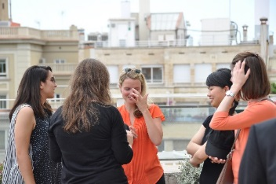

Introduction to Spanish Legal Proceedings

On the second day of the legal seminar Mr Daniel Solsona Hollenstein, lawyer at Marco Legal, introduced Spanish Legal Proceedings to the group.

He started the conference by explaining that there are two legal actors – the abogado who is a lawyer and the procurador who is the agent in court who formally represents the client. The procurador needs to be empowered by the client. Once this has happened, he has to sign writs, submit applications to court etc. Subsequently Mr Solsona Hollenstein taught the Spanish court system to the young lawyers. At this juncture, he explained that Spain is subdivided into 17 autonomous communities, which in turn are subdivided into 50 provinces.
The Spanish court system has three instance which are:

- 1st instance: It consists of 431 1st instance courts spread all over Spain. Concerning commercial courts, there are only 50 which are located in the 50 province capitals.
- 2nd instance: It consists of the 50 Courts of Appeal which are located in the province capitals.
- 3rd instance: It consists of the 17 Superior Justice Courts of the autonomies and the Spanish Supreme Court which is located in Madrid.

There are 17 Superior Justice Courts because the single autonomies have different civil laws - the access to the 3rd instance is very restricted. Some years ago Spanish lawyers always appealed when they lost a case, in consequence, the access was limited by only permitting cases to 3rd instance courts which involve at least a litigation value of 1.5 million Euro or deal with new laws. The average duration of a proceeding is (the numbers doesn’t apply to commercial courts):
1st instance: 7,6 months, 2nd instance: 7,5 months, 3rd instance: 11,7 months. A hearing consist of the following steps:

- New facts and procedural issues can be brought up
- Examination of the:
a) parties (legal representatives)
b) witnesses
c) experts
- Examination of evidences
- Final speech by the lawyers
- Judgement

The different types of main proceedings are:

- Preliminary disclosures
- Precautionary measures
- Ordinary proceedings
- Verbal proceedings
- Monitorios (which is the Spanish payment order)
- Enforcements
- Cheque / promissory note enforcements
- Insolvency proceedings

At the end of the conference, the participants themselves held presentations about the access to the law profession in their different jurisdictions. Thereby, the young lawyers had the opportunity to learn about other countries systems and to compare the different ways of education in different European countries such as Spain, Turkey, Italy, Belgium and Germany.

Commercial Arbitration / ICC Rules (Lopez)

On the third day of the Alliuris Summer School, the young lawyers took part in the Commercial Arbitration course taught by Mr José Luís Terrón, senior associate at ALLEN & OVERY. He is an expert in the area of Commercial Arbitration / ICC Rules. Arbitration is a form of alternative dispute resolution. It is a technique to settle disputes outside the court, where the parties to the dispute transfer the conflict to one or more persons by whose decision they agree to be bound. Arbitration is a resolution technique in which a third party reviews the evidence in the case and imposes a decision that is legally binding for both sides and enforceable. It is often used for the resolution of commercial disputes, particularly in the context of international commercial transactions. The conference started with the question “Why international arbitration?”. The young lawyers discussed about the features of arbitration like enforceability, flexibility, confidentiality, finality and neutrality.

The seminar focused on Arbitration clause drafting. The key drafting issues are:

- clear and binding submission to arbitration
- rules vs. ad hoc proceeding
- the seat or place of arbitration
- the number of arbitrators and method of appointment
- language

In case of multiple claimants/respondents, the multiple claimants, jointly, and the multiple respondents, jointly, shall nominate an arbitrator. In the absence of joint nomination, the court can appoint each member of the arbitral tribunal to act as a chairman. At this juncture, it is important to consider the selecting features of the arbitrators such as for example special knowledge in a certain field of law or a language.
Mr José Terrón presented grounds for the challenge of arbitrators and the group discussed about the lack of impartiality and independence. An arbitrator must remain independent and impartial and shall disclose all facts relevant to the case. Impartiality means neither favouring one party nor being predisposed to the question in dispute. Independence comprises no actual or past dependence between a party and the arbitrator. Towards the end of the conference, Mr Terrón presented the procedure of examination of witnesses and cross-examination. This insight was really interesting. He explained how important it is to choose witnesses. For an arbitration case a witness is needed for its direct and detailed knowledge of facts. The witness is selected even before filing the memorandum for the claimant or respondent. After the selection, the witness has to be prepared. The preparation of witnesses is allowed in international arbitration. But it is important to know that the preparation is not a process whereby the witness is told the answers. It is rather an opportunity to refresh the witness’s recollections of the relevant events, to review contemporaneous documents and to prepare the witness for what is likely to happen during the examination process. The cross-examination may be the last opportunity to change the arbitrators minds if they are leaning towards the other party to the dispute. Cross-examination is about sending a message to the tribunal about the weaknesses of the witness’s testimony. It is not necessarily because the witness was lying or stretching the truth – often it is about what the witness didn’t say or about the fact that the witness's testimony is incompatible with the party's legal theory. In summary, the conference was very exciting for all the young lawyers, especially because everything Mr Terrón taught is highly relevant in practice.

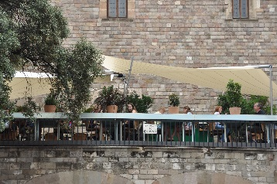
The City of Barcelona ( Tonia)

Barcelona is the second biggest city in Spain and the capital of Catalonia. Barcelona, which calls itself the “Capital of the Mediterranean”, is characterised by a rich and various social, cultural and artistic life. During the Alliuris Summer School the attendants had the chance to explore the Catalan capital. Besides the visit of the Sagrada Família, the Ramblas or Gaudí’s buildings, Marco Legal organised a guided visit to Barcelona’s Gothic District which was impressive for all the young lawyers. To experience the Mediterranean side of Barcelona, the wonderful hosting firm arranged a sailing trip to the Mediterranean Sea which started at the old harbour, ended at the Olympic harbour and ended in eating Paella next to the beach. Besides the impressions of the city of Barcelona, the Summer School was a nice experience for the participants because the Spanish hosting firm warmly welcomed all the young lawyers and everyone of Marco Legal was highly involved in Summer School.
